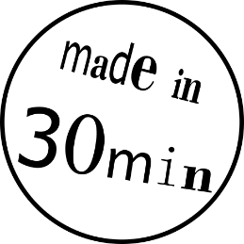3D-PRINT YOUR OWN BOOKMARK

These instructions show you how to design and 3D-print your own bookmark!

Overview:

|  |  |
| --- | --- |
| The first step is to design your 3D-model in the easy-to-use CAD-program Tinkercad. | The process “slicing” then translates the 3D-model into the language of the 3D-printer, the G-code. |
| The G-code is sent to the 3D-printer, which creates your object by melting and depositing layers of plastic filament | Finally, you will hold your first 3D-print in your own hands. The print will be yours to take home! |

Get started:

1. Click the Tinkercad icon  on the desktop. If you are asked to log in, please call an explainer!
2. If the site is already open, click the  logo in the top left corner.
3. If the website is not in English scroll to the bottom of the page, click on the language next to the small globe  and **select English**. Now scroll back up.
4. Click the button . This opens the work plane you can draw on.
5. 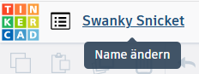Give your design a name. Next to the Tinkercad logo you’ll find a weird text. Click on it and enter “Bookmark_Yourfirstname” (without quotation marks) instead.
6. On the right-hand side you can see various shapes. Select the red shape “box” by clicking on it once. a
7. Drag the box by moving the mouse pointer to the blue work plane.
8. Drop the shape in the centre of the work plane by clicking the desired spot once.
9. Now click the small white square  in the middle of the red box. The standard height of 20.00 mm is displayed. Change that to 1 mm.
10. Click one of the small white squares at the corners of the red box. Change the width (above or below the red box) to 25 mm and the length (to the left or right of the red box) to 70 mm
11. Pick the striped box from the shapes on the right and drag it to the work plane. Change the width to 16 mm and the length to 2 mm (see step 12).
12. 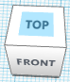Below the Tinkercad logo you can see a small cube. You can change the view of your drawing to looking from above if you click on the word “TOP” inside the cube.  
    You can also hold the right mouse button and move the mouse slowly to change the view.
13. 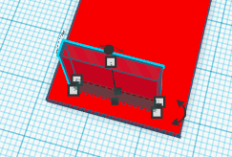Drag the striped box onto your red box, positioning it near the bottom, leaving some space from the edge of the red box. If this sounds confusing, look at the bookmark on the instructions and imagine you are positioning the bottom part of the U-shaped hole!
14. Pick another striped box. Change the width to 2 mm and the length to 40 mm.
15. 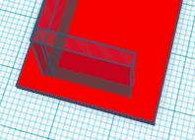Move that box right against the first striped one so they meet like the letter “L”. Make sure you make them meet properly; it does not matter if they overlap!
16. Select the new box by clicking it, copy it by pressing  +  and paste it by pressing  +  .
17. Move the new box opposite the second one. It should look like the third side of the “U” now.
18. Press  +  to select all parts of your design and press  +  to group them. You can see that the striped parts have been cut out of your design, they are now holes!

**YOU ARE DONE! Ask an explainer for the next steps**

* 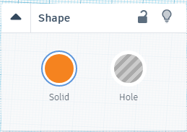You can modify your bookmark by adding shapes.
* Every shape can be turned into a hole by clicking on it and selecting “Hole” in the shape properties next to the shape toolbox. After you have added any shapes, repeat step 18.